Fireside Chats: Working in AI at Microsoft, Salesforce, and Woebot Labs

## [Jasmine Campos](https://student.emeritus.org/courses/3412/users/82697)

WednesdayLocal: Sep 22 at 5:01pm<br>Course: Sep 22 at 9:01pm

[Manage Discussion Entry](https://student.emeritus.org/courses/3412/discussion_topics/189339)

I found the fireside chat with Kathy Baxter, Principal Architect of Ethical AI Practice at Salesforce, very interesting specifically the fact about how  AI/ML models can have bias based on how it is trained. Therefore it becomes really important to be aware of how AI is designed to improve instead of amplify the "weaknesses" in human decisions.

I agree that there needs to be a deliberate focus to develop AI governance models/principles and commit to "Responsible AI" efforts to protect human rights. How do we ensure that as we pursue future technologies that they are designed to make the world a better place and improve human conditions.

[Collapse Subdiscussion](https://student.emeritus.org/courses/3412/discussion_topics/189339)[Mark Penna](https://student.emeritus.org/courses/3412/users/164256)

## [Mark Penna](https://student.emeritus.org/courses/3412/users/164256)

WednesdayLocal: Sep 22 at 8:54pm<br>Course: Sep 23 at 12:54am

[Manage Discussion Entry](https://student.emeritus.org/courses/3412/discussion_topics/189339)

Agreed!  I like the forward thinking about pitching the AI Ethicist role within Salesforce and what it has become.

[Collapse Subdiscussion](https://student.emeritus.org/courses/3412/discussion_topics/189339)[Marco Carranza](https://student.emeritus.org/courses/3412/users/90865)

## [Marco Carranza](https://student.emeritus.org/courses/3412/users/90865)

ThursdayLocal: Sep 23 at 6:32pm<br>Course: Sep 23 at 10:32pm

[Manage Discussion Entry](https://student.emeritus.org/courses/3412/discussion_topics/189339)

Hi Jasmine, i also found the chat Kathy Baxter very interesting. Is crazy how the bias is present in some machine learning products, and is very obvious when your skin is darker.

There was and algorithm named PULSE that is used to upscale pixelated images, the problem is that is too obvious the racial bias, for example when upscaling an image of Obama or one Lucy Liu.

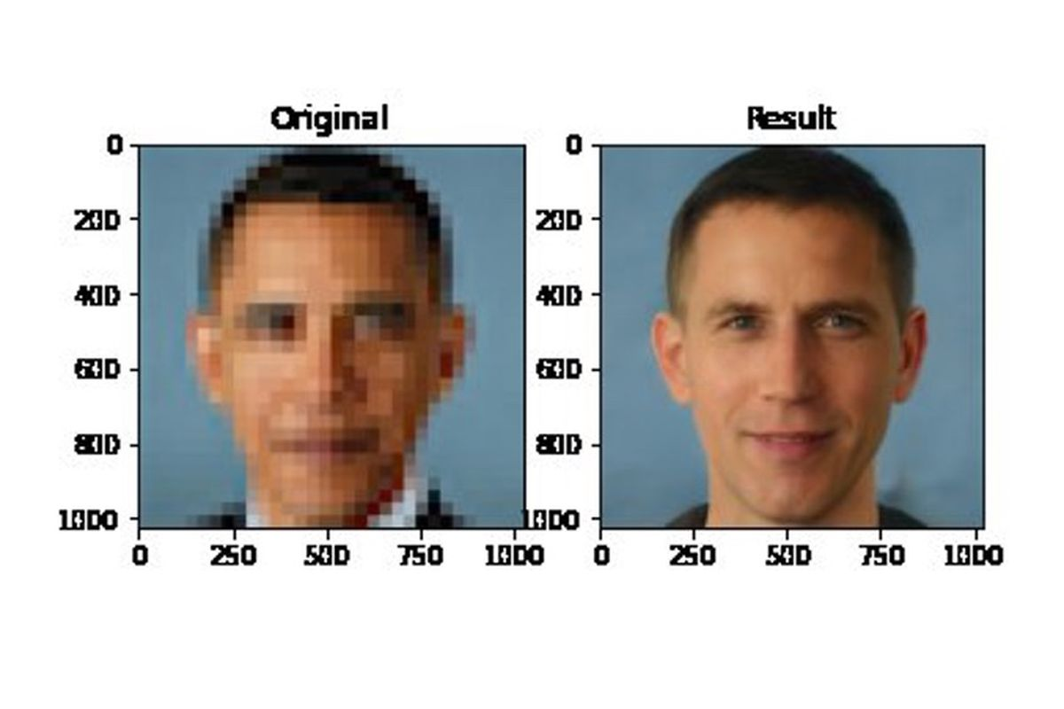

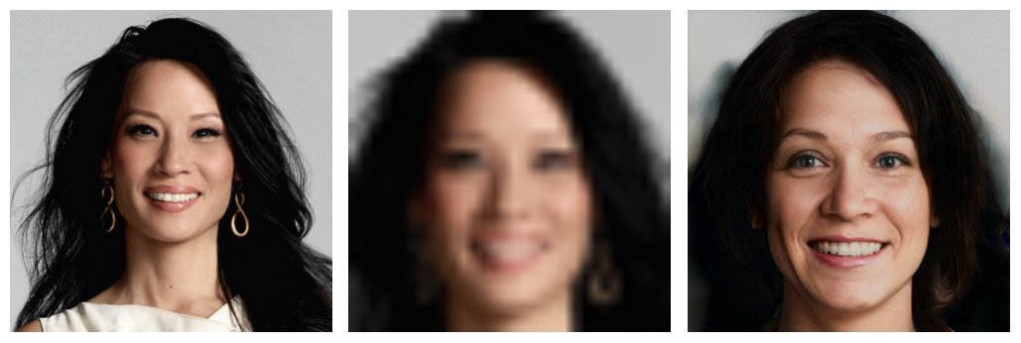

Hope the researchers in the  future are able to reduce the bios of the msot important Machine Learning Algorithms.

Sources:

[https://www.theverge.com/21298762/face-depixelizer-ai-machine-learning-tool-pulse-stylegan-obama-biasLinks to an external site.](https://www.theverge.com/21298762/face-depixelizer-ai-machine-learning-tool-pulse-stylegan-obama-bias)

[https://twitter.com/osazuwa/status/1274445362237972486?ref_src=twsrc%5Etfw%7Ctwcamp%5Etweetembed%7Ctwterm%5E1274445362237972486%7Ctwgr%5E%7Ctwcon%5Es1_&ref_url=https%3A%2F%2Fwww.theverge.com%2F21298762%2Fface-depixelizer-ai-machine-learning-tool-pulse-stylegan-obama-biasLinks to an external site.](https://twitter.com/osazuwa/status/1274445362237972486?ref_src=twsrc%5Etfw%7Ctwcamp%5Etweetembed%7Ctwterm%5E1274445362237972486%7Ctwgr%5E%7Ctwcon%5Es1_&ref_url=https%3A%2F%2Fwww.theverge.com%2F21298762%2Fface-depixelizer-ai-machine-learning-tool-pulse-stylegan-obama-bias)

## [Rosalind Beasley](https://student.emeritus.org/courses/3412/users/162600)

WednesdayLocal: Sep 22 at 8:34pm<br>Course: Sep 23 at 12:34am

[Manage Discussion Entry](https://student.emeritus.org/courses/3412/discussion_topics/189339)

The Fireside Chat with Orlagh Neary, Senior Director at Microsoft AI and Innovation, sparked my interest because it was very down-to-earth and practical advice.  She points out that the AI team needs to be diverse and that innovation doesn't come from engineers alone. It comes from different perspectives and colliding ideas!  Also, she describes how AI innovation isn't always glamorous.  Sometimes, it's about finding practical ways to automate existing processes and decision-making, which is what I hope to do.

## [Jasmine Campos](https://student.emeritus.org/courses/3412/users/82697)

ThursdayLocal: Sep 23 at 2:11pm<br>Course: Sep 23 at 6:11pm

[Manage Discussion Entry](https://student.emeritus.org/courses/3412/discussion_topics/189339)

Agreed. Diversity in AI design thinking  is a really good and strategic approach!

## [Shailendra Singh](https://student.emeritus.org/courses/3412/users/156591)

WednesdayLocal: Sep 22 at 10:28pm<br>Course: Sep 23 at 2:28am

[Manage Discussion Entry](https://student.emeritus.org/courses/3412/discussion_topics/189339)

Kudos to Kathy Baxter. We need more people like her. Very thoughtful, and very clear in her vision about ethics in AI.  I have always worried that just like social media has now become the tool for manipulation and misinformation, AI will have even more serious negative impact on the the society. Wishing her all the success.

[Reply Reply to Comment](https://student.emeritus.org/courses/3412/discussion_topics/189339)(2 likes)

[Collapse Subdiscussion](https://student.emeritus.org/courses/3412/discussion_topics/189339)[Jesse Oman](https://student.emeritus.org/courses/3412/users/161721)

## [Jesse Oman](https://student.emeritus.org/courses/3412/users/161721)

ThursdayLocal: Sep 23 at 8:19am<br>Course: Sep 23 at 12:19pm

[Manage Discussion Entry](https://student.emeritus.org/courses/3412/discussion_topics/189339)

I couldn't agree more.  I think this is vital to ensuring the appropriate usage of AI in the future.

## [Petite Silvey](https://student.emeritus.org/courses/3412/users/164987)

WednesdayLocal: Sep 22 at 11:15pm<br>Course: Sep 23 at 3:15am

[Manage Discussion Entry](https://student.emeritus.org/courses/3412/discussion_topics/189339)

Both Kathy Baxter and Orlagh Neary emphasized the importance of ethics and a moral compass, that a company is responsible for what they create and release into the world.. They must be accountable and responsible. Ethics and security require guidelines and standards within every organization especially as more data and a greater exchange of ideas is possible.

## [Yavuz Kurt](https://student.emeritus.org/courses/3412/users/164312)

WednesdayLocal: Sep 22 at 11:26pm<br>Course: Sep 23 at 3:26am

[Manage Discussion Entry](https://student.emeritus.org/courses/3412/discussion_topics/189339)

I also like Kathy Baxter, especially as she is being a part of a working group @ the World Economic Forum project called Generation AI. Setting up rules and guidelines for the followers especially at that level is so important...  because that has a huge effect on the participants and their followers.

[Collapse Subdiscussion](https://student.emeritus.org/courses/3412/discussion_topics/189339)[Mosongo Moukwa](https://student.emeritus.org/courses/3412/users/86918)

## [Mosongo Moukwa](https://student.emeritus.org/courses/3412/users/86918)

ThursdayLocal: Sep 23 at 1:37am<br>Course: Sep 23 at 5:37am

[Manage Discussion Entry](https://student.emeritus.org/courses/3412/discussion_topics/189339)

I agree. Governance is an area to watch as society should strive to use and apply AI responsibly.

## [Adam Salmen](https://student.emeritus.org/courses/3412/users/144005)

WednesdayLocal: Sep 22 at 11:31pm<br>Course: Sep 23 at 3:31am

[Manage Discussion Entry](https://student.emeritus.org/courses/3412/discussion_topics/189339)

I also liked the Orlagh discussion, and actually reached out to her and had a great converssation (on linkedin)... I thin our company is at a point where we need to find off-the-shelf products which can help us along the journey... even if it is, as Olaf says, a frenemy type relationship...

I think working with the "deep pockets" type companies such as Microsoft to help us get started on the path of implementing AI...

## [Mosongo Moukwa](https://student.emeritus.org/courses/3412/users/86918)

ThursdayLocal: Sep 23 at 1:35am<br>Course: Sep 23 at 5:35am

[Manage Discussion Entry](https://student.emeritus.org/courses/3412/discussion_topics/189339)

I watched the 3 videos. What stood with me is the duality that we are dealing with. AI can be for Good, but also for Evil. The use of AI has raised a number of concerns, among them ethical.

AI can be seen as a technology for Good like using this technology to help researchers in the fight against Covid-19  (Orlagh Neary), or in providing access to cognitive therapy (Alison Darcy). At the same time, AI raises ethical concerns. For example, will AI make fake news worse? Those concerns are transparency (Alison Darcy) be bias in the data that gets perpetuated (Orlagh Neary) with disastrous results such as for example screening out women for certain roles (Kathy Baxter). This call for some sort of governance. Kahy Baxter put it this way “Identify ethical risks and considerations and put guidelines in place to help them create our technology more responsibly, but then also putting in guard rails, in-app education, tools to help our customers then use our technology more responsibly.”

## [Adam Salmen](https://student.emeritus.org/courses/3412/users/144005)

WednesdayLocal: Sep 22 at 11:31pm<br>Course: Sep 23 at 3:31am

[Manage Discussion Entry](https://student.emeritus.org/courses/3412/discussion_topics/189339)

I also liked the Orlagh discussion, and actually reached out to her and had a great converssation (on linkedin)... I thin our company is at a point where we need to find off-the-shelf products which can help us along the journey... even if it is, as Olaf says, a frenemy type relationship...

I think working with the "deep pockets" type companies such as Microsoft to help us get started on the path of implementing AI...

## [Mosongo Moukwa](https://student.emeritus.org/courses/3412/users/86918)

ThursdayLocal: Sep 23 at 1:35am<br>Course: Sep 23 at 5:35am

[Manage Discussion Entry](https://student.emeritus.org/courses/3412/discussion_topics/189339)

I watched the 3 videos. What stood with me is the duality that we are dealing with. AI can be for Good, but also for Evil. The use of AI has raised a number of concerns, among them ethical.

AI can be seen as a technology for Good like using this technology to help researchers in the fight against Covid-19  (Orlagh Neary), or in providing access to cognitive therapy (Alison Darcy). At the same time, AI raises ethical concerns. For example, will AI make fake news worse? Those concerns are transparency (Alison Darcy) be bias in the data that gets perpetuated (Orlagh Neary) with disastrous results such as for example screening out women for certain roles (Kathy Baxter). This call for some sort of governance. Kahy Baxter put it this way “Identify ethical risks and considerations and put guidelines in place to help them create our technology more responsibly, but then also putting in guard rails, in-app education, tools to help our customers then use our technology more responsibly.”

## [Muralidhar Gowda](https://student.emeritus.org/courses/3412/users/145255)

ThursdayLocal: Sep 23 at 3:18am<br>Course: Sep 23 at 7:18am

[Manage Discussion Entry](https://student.emeritus.org/courses/3412/discussion_topics/189339)

The Fireside Chat with Orlagh Neary, Senior Director at Microsoft AI and Innovation, caught my interest because it was simple and clear for me to follow and relate to. She pointed at  Fear Involved in AI,  commented on Leadership responsibilities in bringing cultural change and building trust in AI development and adoption.  Highlighted AI is not  Engineering change but Cultural Change, which  also includes Change Management, Process  and Communication. My  key take away includes her  advice on Blockers ,tips on AI  Readiness assessment  for beginners, Why and how AI  “Pilot” to be used within AI journey.

## [Nikunj Patel](https://student.emeritus.org/courses/3412/users/145235)

ThursdayLocal: Sep 23 at 12:58pm<br>Course: Sep 23 at 4:58pm

[Manage Discussion Entry](https://student.emeritus.org/courses/3412/discussion_topics/189339)

Very forward thinking , really like real example on where AI was successful and were it struggle to provide benefit in their business.

## [Scott Roosa](https://student.emeritus.org/courses/3412/users/163238)

ThursdayLocal: Sep 23 at 3:45pm<br>Course: Sep 23 at 7:45pm

[Manage Discussion Entry](https://student.emeritus.org/courses/3412/discussion_topics/189339)

I found the AI ethicist discussion with Kathy very interesting.  I always struggle with AI bias...  I am not too sure how we can ever remove all bias but I like the approach discussed about having standards and groups that can review and provide feedback across many different perspectives.

## [Federico Giannangeli](https://student.emeritus.org/courses/3412/users/151424)

ThursdayLocal: Sep 23 at 6:56pm<br>Course: Sep 23 at 10:56pm

[Manage Discussion Entry](https://student.emeritus.org/courses/3412/discussion_topics/189339)

The bias is already a challenging topic in our day to day life.   If we couple it with a AI, I agree with Kathy Baxter that it just get amplified not only mirrored.   The example of google translate in a language that is gender-neutral is a great example.

All the videos made me reflect in something, if AI is as sort of augmented lens of the bias, and human being by nature introduce “unconsciously” bias statement and positions that appear unnoticeable in our routine life, how is that we are not using more AI to help us identify our pitfalls.

Last but not least, Orlagh Neary, made an interesting example associated to “limit of time” when a programmer is working an AI solution (i.e. time constraints to deliver a product put in lower priorities the bias part task).  I fully agree with her position, we need to see an AI solution not only from its breakthrough of programming related task but the ethics is an equal important part of it.  If we evolve culturally in that way, we will never handover a AI solution as completed before all tasks are done (including the AI responsible check)

## [Jerry Li](https://student.emeritus.org/courses/3412/users/139854)

SaturdayLocal: Sep 25 at 1:31pm<br>Course: Sep 25 at 5:31pm

[Manage Discussion Entry](https://student.emeritus.org/courses/3412/discussion_topics/189339)

I love the concept of "Ethical by Design" from Kathy Baxter, specially using "Inclusive language". We usually focus on inclusion out of technology but her team's work opens a new front line of how to enable future technology to be accepted by all of us.

[Jinmi](https://student.emeritus.org/courses/3412/users/163394)

## [Jinmi](https://student.emeritus.org/courses/3412/users/163394)

SaturdayLocal: Sep 25 at 10:31pm<br>Course: Sep 26 at 2:31am

[Manage Discussion Entry](https://student.emeritus.org/courses/3412/discussion_topics/189339)

All three discussions are thought provoking. Particularly around the topic of bias detection and ethical responsible AI design. I also liked Kathy's point that value and cultural system can deeply influence the definition of "ethical", so perhaps it is equally important the conversation about what ethical responsible AI entails need to happen at global level and include diverse people with different background as well.  I am also intrigued that AI is being applied in area that is deeply human interaction (e.g. mental heath therapy) in Alison's company, and the thought of having future personal assistant that can bring new levels of self-awareness is also fascinating. Perhaps it can also guard us from being exploited by "bad AI" as well? :) .

## [Kenneth Kabaki](https://student.emeritus.org/courses/3412/users/145896)

YesterdayLocal: Sep 26 at 10:53am<br>Course: Sep 26 at 2:53pm

[Manage Discussion Entry](https://student.emeritus.org/courses/3412/discussion_topics/189339)

AI bias is certainly something that we should all be cognizant of.  AI is here to stay and will only continue to be more integrated into our lives.  I am glad that companies such as Salesforce have recognized AI bias and have put in systems to mitigate against this issue.

I recently read a good book by Cathy O'neal that gives a couple of examples of these biases. The book a good book, [Weapons of Math Destruction: How Big Data Increases Inequality and Threatens DemocracyLinks to an external site.](https://www.amazon.com/Weapons-Math-Destruction-Increases-Inequality/dp/0553418815)is quite an illuminating read.